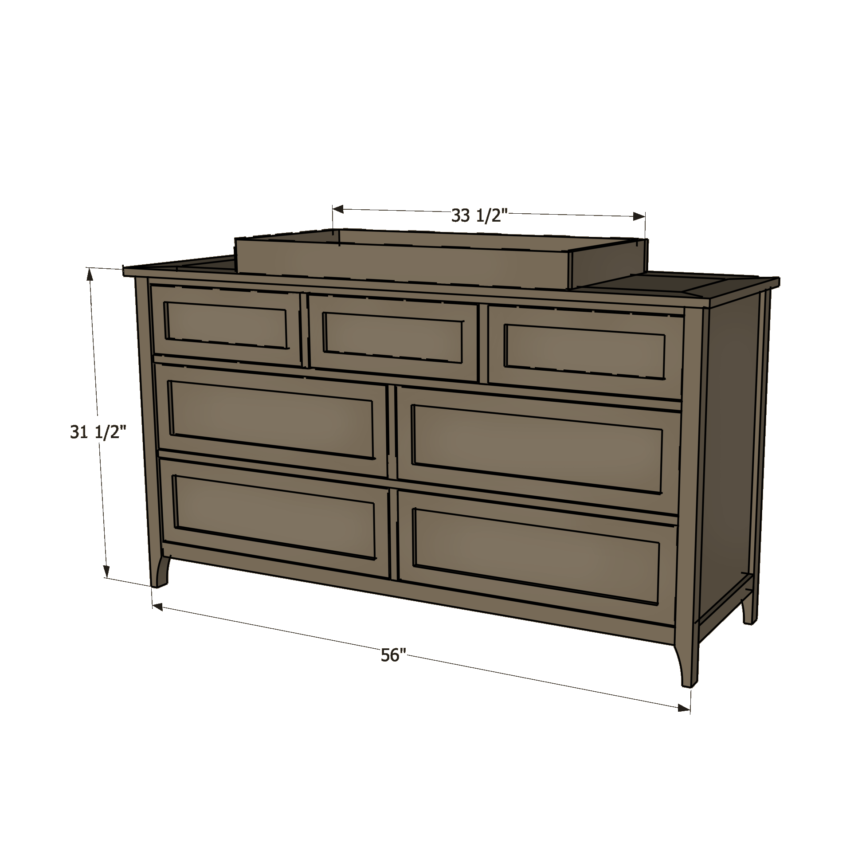
DIY 7-Drawer Dresser
Instructions by Build-Basic.com

DIY 7-Drawer Dresser
Instructions by Build-Basic.com
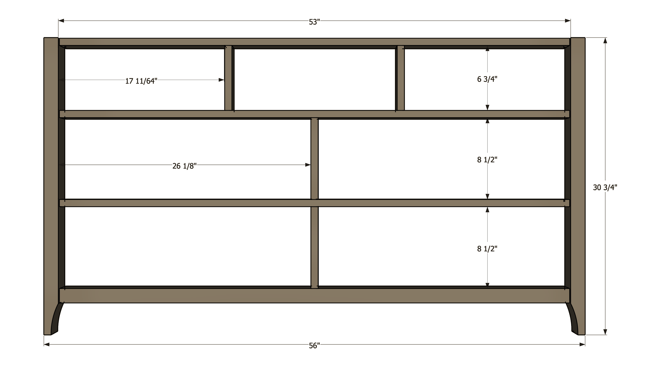

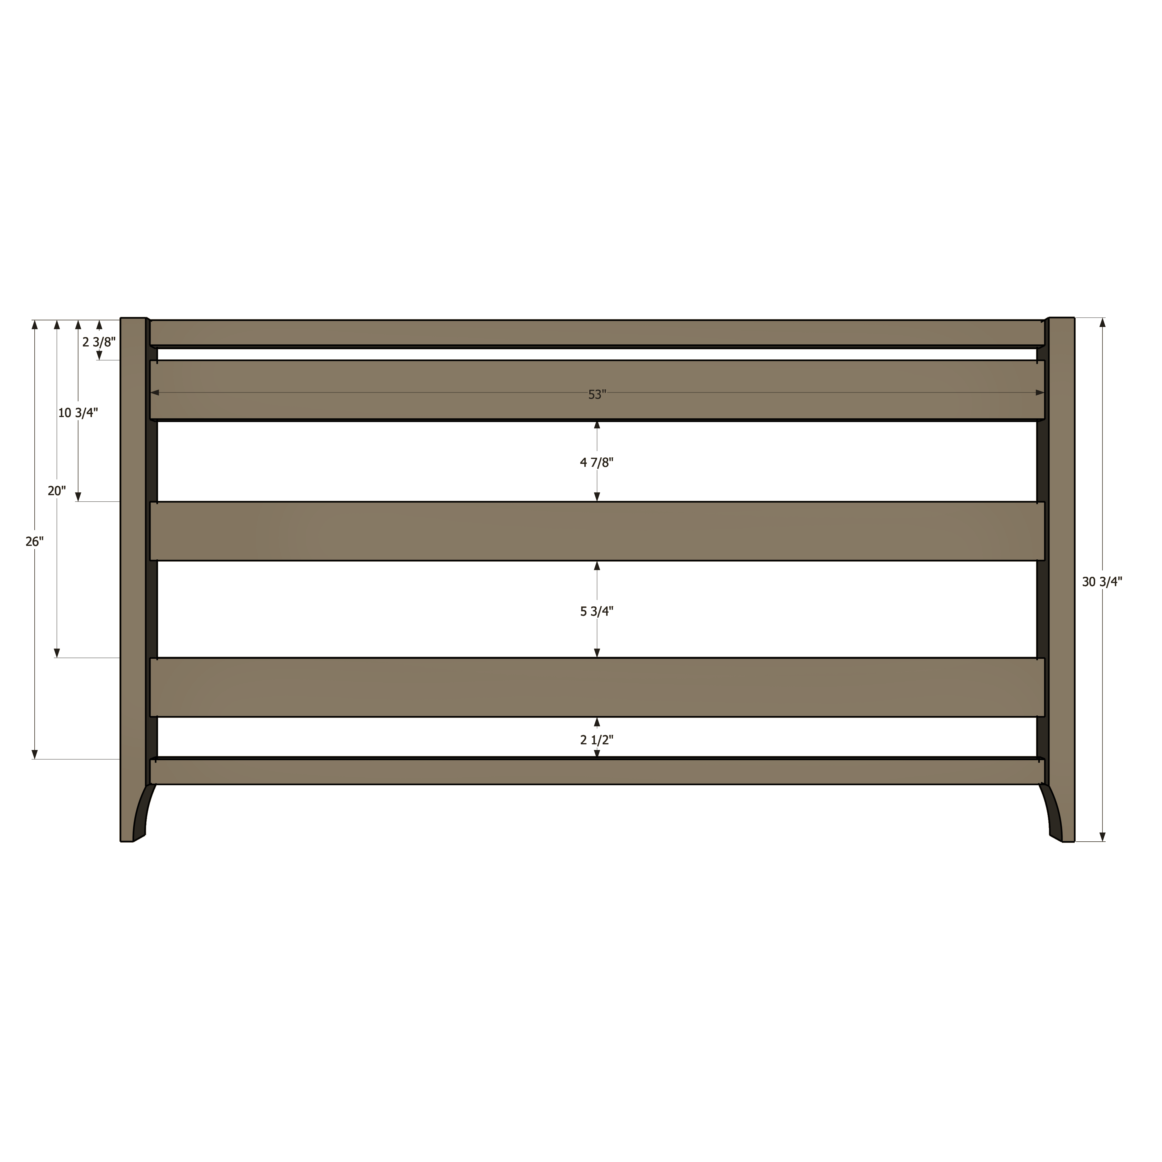

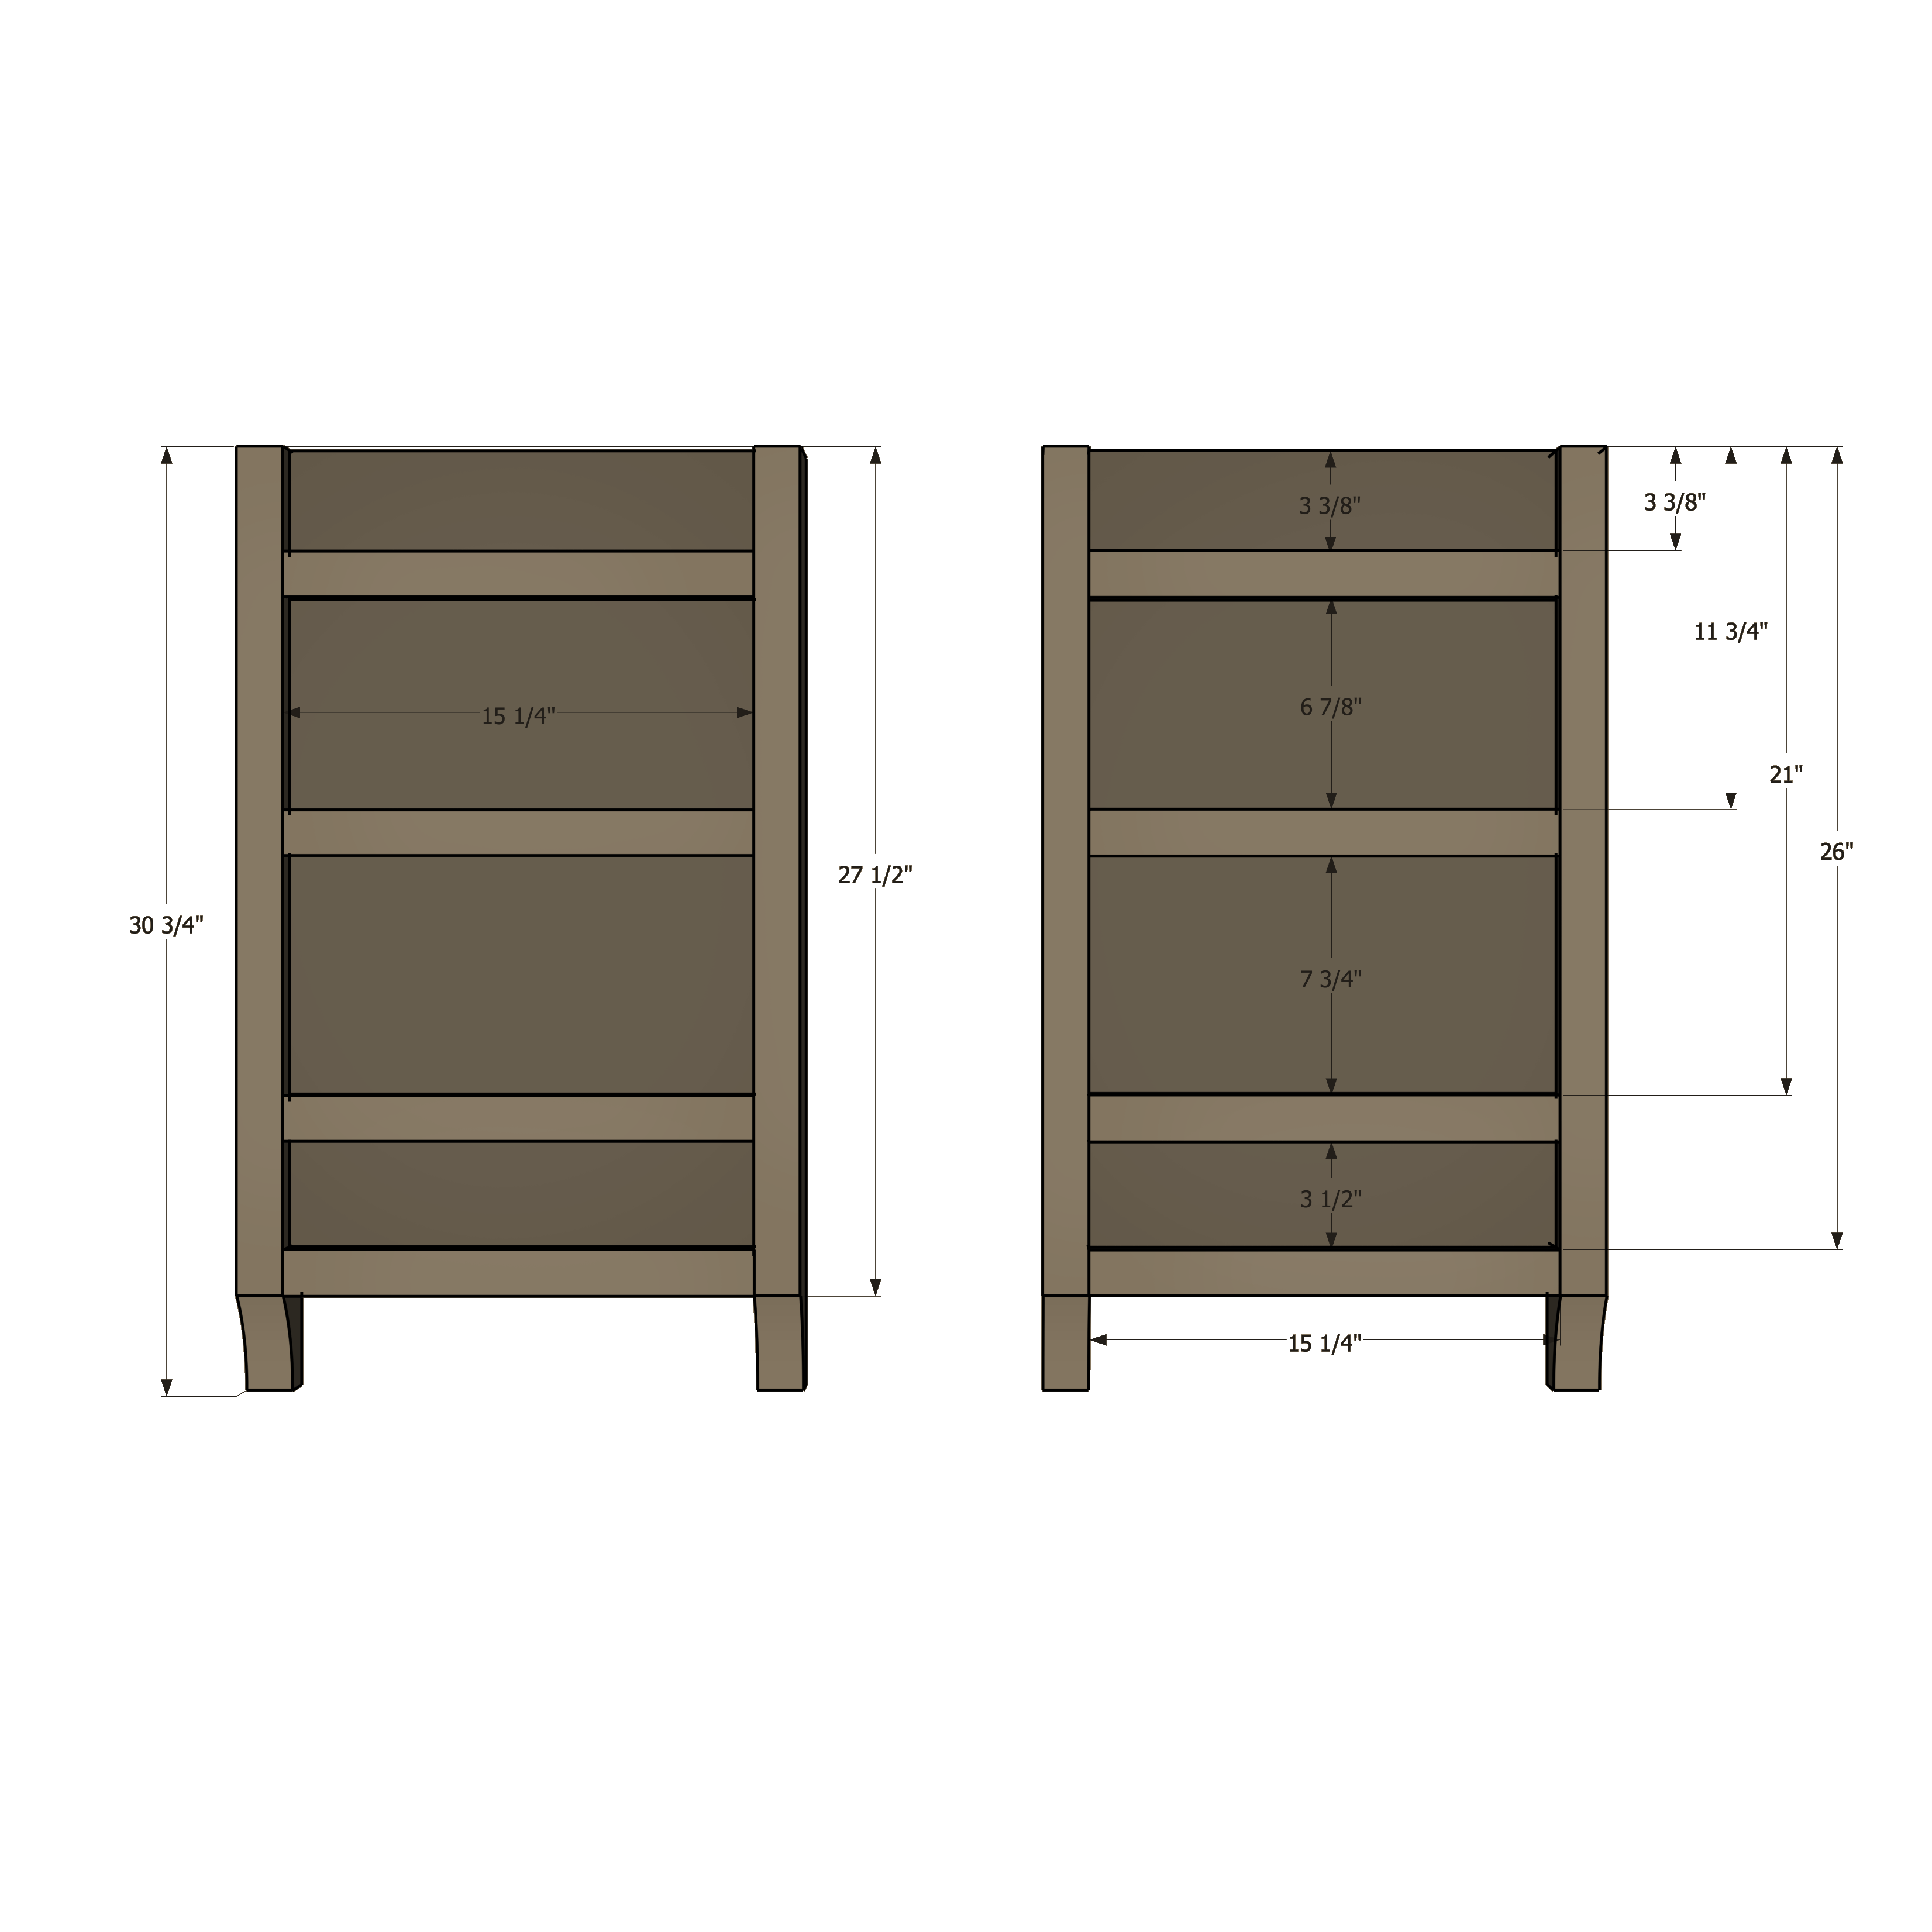
DIY 7-Drawer Dresser
Instructions by Build-Basic.com

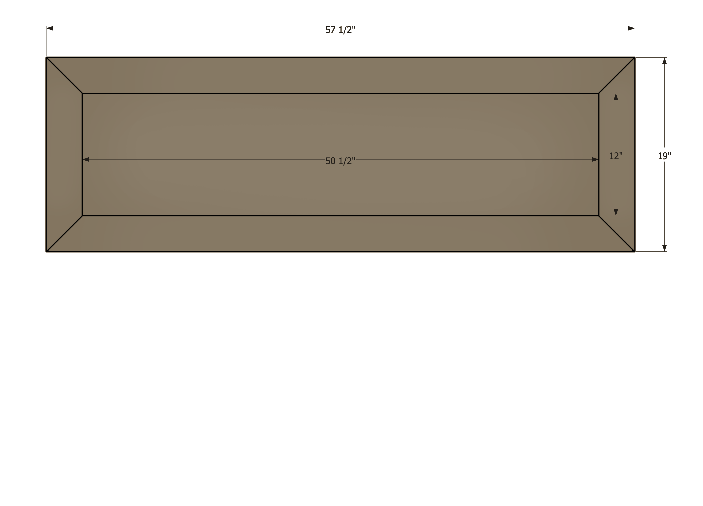

DIY 7-Drawer Dresser
Instructions by Build-Basic.com
Body
- 2 x 2 Legs – 4 @ 30¾ inches
- 1 x 2 Rails – 5 @ 53 inches
- 2 x 2 Rails – 1 @ 53 inches
- 1 x 2 Stiles – 2 @ 6¾ inches
- 1 x 2 Stiles – 2 @ 8½ inches
- 1 x 2 Side Rails – 4 @ 15¼ inches
- 1 x 4 Back Rails – 3 @ 53 inches
- 1 x 4 Supports – 4 @ 16 3/8 inches
- ½-inch Plywood Drawer Slide Padding – 6 @ 1½"H x 15¼"W

Top
- 1 x 4 Frame Top – 2 @ 19 inches (miter ends at 45-degrees)
- 1 x 4 Frame Top – 2 @ 57½ inches (miter ends at 45-degrees)
- ¾-inch Plywood Top – 1 @ 50½" x 12"

Topper (Optional)
- 1 x 3 Topper Ends – 2 @ 16½ inches
- 1 x 3 Topper Front and Back – 2 @ 33½ inches

Small Drawer Boxes
- ½-inch Plywood Small Drawer Sides – 6 @ 6¼"H x 16"W
- ½-inch Plywood Small Drawer Fronts and Backs – 6 @ Cut to fit 6¼"H x 2-inches less than the width of opening
- 3/8 Square Dowel Cleats – 6 @ 14½ inches
- 3/8 Square Dowel Cleats – 6 @ Cut to fit Width of Drawer Fronts and Backs

Large Drawer Boxes
- ¾-inch Plywood Large Drawer Sides – 8 @ 8"H x 16"W
- ¾-inch Plywood Large Drawer Fronts and Backs – 8 @ Cut to fit 8"H x 2½-inches less than the width of opening
- 3/8 Square Dowel Cleats – 6 @ 14½ inches
- 3/8 Square Dowel Cleats – 6 @ Cut to fit Width of Drawer Fronts and Backs

Small Drawer Fronts
- 1 x 2 Small Drawer Front Frames Top and Bottom – 6 @ Cut to fit ¼ inch less than the width of opening
- 1 x 2 Small Drawer Front Frames Sides – 6 @ 3½ inches
- ½-inch Plywood Small Drawer Front Panels – 3 @ Cut to Fit inside Frame

Large Drawer Fronts
- 1 x 2 Large Drawer Front Frames Top and Bottom – 8 @ Cut to fit ¼ inch less than the width of opening
- 1 x 2 Large Drawer Front Frames Sides – 8 @ 5¼ inches
- ½-inch Plywood Large Drawer Front Panels – 4 @ Cut to Fit inside Frame

Backing
- ½-inch Plywood - 1 @ 53"W x 27½"H

